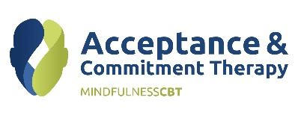
Acceptance & Commitment Therapy (ACT) As a Brief Intervention
Learn practical techniques and develop your skills of using ACT as a brief intervention.
Overview

This workshop is designed for clinicians who have already completed an ACT Introductory Workshop. The aim is to for participants to learn practical techniques on using ACT as a brief intervention within a variety of settings.
This workshop will introduce participants to ‘Focused Acceptance and Commitment Therapy’ (FACT), a brief, powerful, contextual behavioral intervention approach rooted in the three principles of acceptance, mindfulness and values based change.
Participants will engage in a range of experiential exercises which are focused on developing knowledge of the different ACT processes and develop practical skills to develop their ACT Clinical Practice.
Objectives
- Review the ACT hexagons – Psychological Inflexibility and Psychological Flexibility
- Learn about the evidence for radical change in therapy
- Try out brief approaches to assessment
- Discover brief, accurate case formulation strategies
- Plan powerful interventions to improve client openness, awareness and engagement
- develop skills in ACT assessment and formulation and the application of ACT to a variety of presenting issues
Who should attend
Clinicians who have already completed any ACT Introductory Workshop. Workshops are inclusive, encouraging and supporting a multidisciplinary approach to the development of ACT knowledge and practice.
Length 1 day from 9am to 4pm
Places are limited. Early booking is essential.
Registration: www.nz-act-training.com
Contact: admin@nz-act-training.com
078080607

