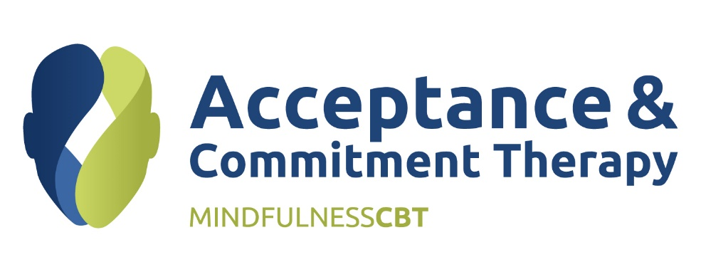
Skills to foster Self-Compassion
Overview
This workshop is designed to help practitioners deepen their understanding and practice of compassion-focused ACT therapy and supporting their clients to develop self-compassion skills. The course is grounded in Compassion Focused Therapy, ACT, Relational Frame Theory (RFT) and elements of Functional Analytic Psychotherapy (FAP).
Objectives
Participants will gain knowledge and understanding of:
- Compassion Focused ACT and applying the fundamentals of Compassionate Flexibility
- Deliberately cultivating compassion and how this can enhance the ACT processes
- Using a compassion focused approach to evidence based techniques such as exposure and response prevention, defusion, and behavioural activation.
- Integrate compassion focused methods into ACT consistent practice.

Course Design

8 weeks – online course with weekly modules culminating in a one day face to face workshop.

