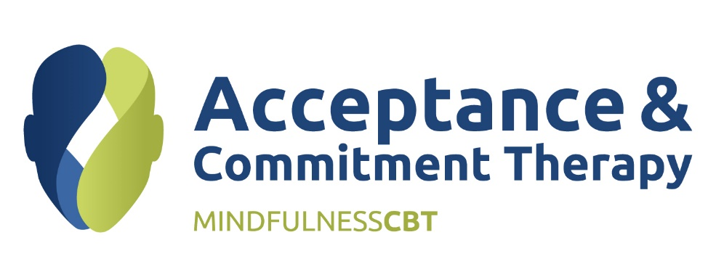
Developing & Expanding Your ACT Skills
Overview
This 2-day workshop is for participants who are already familiar with Acceptance and Commitment Therapy (ACT) and wish to deepen their knowledge, skill, and flexibility when applying ACT in a range of different settings. Thus, this intensive training will go more deeply into the nuanced application of ACT, with a focus on learning how to apply ACT more flexibly and fluidly in practice.

Objectives
Participants will gain knowledge and understanding of:
- Identifying ACT clinical processes and conceptualise clinical concerns within an ACT framework
- Speaking and responding to clients using ACT consistent language
- Creating a powerful therapeutic context for change to empower clients to make meaningful life changes
- ACT intervention strategies
- Becoming ‘unstuck’ in therapy

Who Should Attend?
Because this is an intermediate to advanced level training, participants should have some prior training / learning experience with ACT. Enrolment will be limited so that we will have greater opportunity to practice skills in pairs and small groups.

Length
2 days from 9am to 4.00pm.

